Chaos Engineering: A Proof of Concept Using Gremlin and Chaos Toolkit
Felipe Barbosa de Oliveira and Matheus de Oliveira Manhães
Sistema de Informação – Universidade do Grande Rio Professor José de Souza Herdy
Rua Professor José de Souza Herdy, 1160 – 25073-200 – Duque de Caxias - RJ Departamento de Sistemas de Informação
Universidade do Grande Rio Professor José de Souza Herdy (UNIGRANRIO) – Duque de Caxias, RJ – Brasil
mmanhaes@unigranrio.br, felipeo@unigranrio.br
Abstract. This paper aims to show the Chaos Engineering process in the execution and creation of experiments simulating work routines, trying to generate turbulence to contribute with the preparation of software engineers for situations where software may become unavailable, such as commons interruptions and response time delay, in order to build resilience and discover weaknesses. This document exemplifies a Chaos Engineering process through four systems: A GitHub user repository finder, a RESTful API for registering useful terms related to Chaos Engineering, a common calculator and a task manager. These applications are a target of Chaos experiments with Gremlin and Chaos Toolkit.
Keywords: Attacks, Chaos Engineering, Experiment, Netflix, Systems.

1. Introduction
What was once considered a taboo on security and privacy issues, today we can see that the use of applications and web systems has been increasingly inherent in the culture and routine of human beings. (MODESTO et al., 2011). We see, for example, how common is the use of Netflix. It is possible to see how much is invested to make Netflix services available to your users in different situations and devices. (LIMA et al., 2015). Studying the structure of large systems helps in how new applications and systems can be built ensuring quality and availability for users. One of the ways that big companies like Netflix, Amazon, Google, Microsoft, Uber and Dropbox can maintain their services with quality is by using Chaos Engineering (ROSENTHAL et al., 2017).
Therefore, the discipline of Chaos Engineering is the focus of this work. By studying its principles, practices and tools we intend to create an environment where it is possible to access applications in a production environment and use them as targets of Chaos experiments, as we believe that when analyzing and implementing this process software engineers or interested in studying this discipline can observe how to contribute to system developments can begin to be thought out in order to reveal their flaws and result in more resilient systems.

1.1. Motivation
One of society's most common hobbies is entertainment, especially television programs, movies, series, and soap operas (JANOWSKI, 2011). Using platforms like Netflix, which is the largest video streaming company in existence today (NETFLIX, 2019). It is possible to see how much effort is invested to have a good structure to ensure availability and quality for its users. By researching what keeps Netflix services always available and with quality, it is possible to find that Chaos Engineering is a contributor. (ROSENTHAL et al., 2017). Not only Netflix, but other large and small companies, if not already adopted, has sought to adopt the actions of the Chaos Engineering discipline. Although a relatively new discipline, it has brought a lot of curiosity and investment from businesses and the web community to check the availability of inserting Chaos into their software development processes, as well as building tools and documents for practice and learning.

1.2. Problem
Analyze the discipline of Chaos Engineering and generate knowledge regarding its routines, building target systems and experiments using its own tools to generate Chaos. With this in mind, this paper aims to solve the following problem:
How to enable a Chaos Engineering process using a calculator, a GitHub user repository finder, a task manager and a RESTful API as targets for experiments that include attack and monitoring, using Chaos Toolkit and Gremlin as attack tools?

1.3. General Objectives
This paper is intended as a proof of concept showing a simulation project of a production environment to serve as a target for Chaos Principle based attacks.

1.4. Specific Objectives
Explore the Chaos Engineering discipline using tools such as Gremlin and Chaos Toolkit with the intention of generating a turbulent environment, hoping to uncover system weaknesses and investing in an attempt to create a resilient and available environment in where the user has no harm in their experience as a consumer of the services offered in the applications.

1.5. Paper Organization
This paper is organized as follows: section 1 describes the introductory part of the problem, as well as the motivation, objectives, and the way the work is organized; Section 2 describes the theoretical framework that addresses Netflix, Chaos Engineering, and the relationship between these two items; Section 3 presents the proof of concept describing the problem, the proposed solution and the research architecture, which describes in detail how the target applications were built and how their interactions work, as well as the preparation of the environment for execution and implementation of the attacks for the Chaos Engineering experiment; Section 4 presents the conclusion of this paper addressing final considerations, contributions, and future work; Finally, section 5 presents the bibliographic references.

2. Theoretical Referential
This section provides a brief history of streaming company Netflix, Inc., and how the discipline of Chaos Engineering was incorporated into company culture until it became common practice in its development process. It will also briefly cover the concept of Chaos Engineering. This section provides a brief history of streaming company Netflix, Inc. and how the discipline of Chaos Engineering was incorporated into company culture until it became common practice. in its development process. It will also be briefly addressed the concept of Chaos Engineering.

2.1. Netflix
According to Netflix (2019), the company has been a leader in digital content since 1997, being one of the leading Internet entertainment services in the world, with nearly 158 million active subscriptions in over 190 countries and content encompassing films, series and documentaries. of various genres and languages. What was initially an online DVD rental service, currently offers its subscribers the ability to watch their content whenever and wherever they want on virtually any screen with an Internet connection.
Noting the growing demand for services offered and the growing user base in 2008, Netflix began a process of migrating its infrastructure from datacenters to the cloud where systems would have better scalability and resource management. (NETFLIX, 2019).
Due to the infrastructure migration process to the cloud, it was found that horizontal scalability would multiply the number of instances running a given service. With thousands of these instances running, it was a matter of time that one of these virtual machines failed for some reason. There was a need for services to be built for resilience (the ability to return to their normal state when unforeseen events occur), (ROSENTHAL et al., 2017). According to IBM (2013), horizontal scalability is the ability to add or subtract nodes to a given system architecture. These nodes can be devices like virtual machines.
Since then, several resilience tests have been performed in the production environment in order to prove the quality of service and operating capacity in a real use scenario. This whole process would later be known as Chaos Engineering. Tools were created to support the process. Chaos Monkey being one of the first to be used, followed by Kaos Kong on a larger scale and FIT (Failure Injection Testing) occupying the gap between the first two. (ROSENTHAL et al., 2017).
In addition, the Chaos Principles were developed, a test automation platform was implemented to continuously run experiments on microservices architecture, and it was observed that Chaos Engineering aims to make visible the chaos already inherent in complex systems.
It's important to note that organizations like Google, Amazon, Microsoft, Dropbox and others in various areas have also been adopting the practice of Chaos Engineering in their development process to make their processes and systems more resilient. (ROSENTHAL et al., 2017).

2.2. The Chaos Engineering Concepts
According to Rosenthal et al. (2017), Chaos Engineering, is a discipline that studies the behavior of a system through experiments designed to build confidence and resilience to withstand daily unpredictability. (ROSENTHAL et al., 2017).
Speaking of “chaos” we can get an idea of something without organization, without logic, and totally uncontrolled. However, Chaos Engineering is not about inducing random failures without any planning or purpose, quite the contrary. Understanding the conditions that can induce these failures and contingencies is the main objective of this discipline.
According to Rosenthal et al. (2017), there is a challenge in maintaining and implementing system improvements that achieve a certain level of growth and complexity with the high number of components interacting with each other. Regardless of the architecture used in the system, with component decoupling we also have a number of factors that can impact its execution. While it is not feasible to predict all failures in a system, many of them can be detected before they are noticed in the execution where the damage is greatest.
The use of experiments makes it possible to reveal system details that would normally go unnoticed causing a future failure. They are not only based on binary test conditions applied to an isolated component but are performed to observe system behavior under various conditions that simulate possible actual failures focusing on critical areas of that system. One example could be a growing number of customers visiting a shopping site, which increases the traffic and generates a higher revenue. In this case, we do not have a flaw in question, but it is a good opportunity for exploration and experimentation on the impact of increasing user numbers on the system from a Chaos Engineering perspective. (ROSENTHAL et al., 2017).
The Chaos Engineering is not restricted to just the technical aspects of applications, in fact, experiments can be applied to the entire system's socio-technical system in the software production chain, including: Users, Third Party Applications, Infrastructure and others. (MILES, 2019).
According to Rosenthal et al. (2017), there are still some prerequisites that the system must follow before we apply Chaos Engineering to a system. The system must meet basic testing and monitoring requirements, as well as be in a normal state of execution with previously known failures properly corrected. The goal of Chaos Engineering is to give visibility to hidden faults.
According to STELLA Report (2017), these failures are called Dark debt, in translation, dark debt, are failures that affect complex systems causing anomalies capable of generating faults with the same complexity in the system. These imperfections in the system are not detectable until the disturbance is noticeable, becoming invisible until the anomaly is exposed.
Another point to note is that the system submitted to the Chaos Engineering process must contain some form of monitoring that allows analysis from the data collected during the execution of the experiments. (MILES, 2019).

2.2.1. Chaos Engineering & Software Testing
When one starts exploring Chaos Engineering, one of the most common questions is how this discipline differs from traditional testing. Table 1 shows a comparison of these two areas and how they differ.
Chaos Engineering uses testing at some specific points in the system, however it is not based solely on this practice. The tests serve as part of the process of knowledge about the experienced system. They indicate whether a specific condition is within standards, while Chaos Engineering seeks to look at the interaction of system components as a whole to correct failures and implement improvements. (ROSENTHAL et al., 2017).

Chaos Engineering | Traditional Tests
Dynamics approach. Unpredictable result. | Logical approach. Analyzes whether the observed result is equal to the expected result.
Checks in specific scenarios that the codes are correct. | Checks if the behavior of the system is correct.
Identifies bugs as far as possible from the production environment. | Identifies bugs as close as possible to the production environment.
Table 1 - Chaos Engineering Comparison with Traditional Testing.

2.2.2. Systemic Complexity
Managing a system is a challenge for any architect responsible for its execution. This challenge multiplies at the same system size ratio. As components are added, complexity increases even more, making it difficult to maintain and requiring more effort from the teams responsible for it.
By adopting the microservice architecture, Netflix faced the difficulty of managing the numerous active services. While on the one hand they allowed teams to work independently, the same architecture generated a greater coordination effort between teams.
Indeed, in both monolithic and loosely coupled architectures such as microservices, as complexity increases, it is humanly impossible for a single individual to gain insight into the behavior and interaction of all its components. This is where Chaos Engineering comes to support, working to improve readability, exhibiting behaviors previously hidden from human eyes (ROSENTHAL et al., 2017).
From a certain point on, classical, functional and integration tests become insufficient due to component integration and an approach that allows us to observe a wider range of interaction is required. It becomes necessary to go beyond the already known properties of the system.
In this scenario we may have something known as the “whip effect” where a slight disturbance in data entry can destabilize the flow of interaction between components by drastically altering the expected output. Without this being detected in standalone tests, in this situation each component would act as expected, but a chain event caused by a certain input would alter the output. (ROSENTHAL et al., 2017).

2.2.3. The Advanced Principles of Chaos
According to Gremlin (2017), when applying chaos engineering the system and its ability to react to real-world random events in a series of experiments are tested, these experiments usually consist of the following steps: Definition of the normal state Hypothesis about the normal behavior of the system and Exposure to simulation of real events. According to Rosenthal (2017), there are still the steps of Experiment Automation and Control over the scope of experiments.
According to variables such as data input and output, error rate, latency and others the normal system state is defined. This would be the normal state of operation of the system, where it behaves in an expected manner GREMLIN (2017). For (ROSENTHAL et al., 2017), there is still one more determining factor to consider that would be the business metrics. Business metrics are based on business rules and the expected behavior of the system to meet them. Also, second (ROSENTHAL et al., 2017), business metrics are the best representatives to measure the actual state of normal system execution, acting as “vital signs” of the system.
The hypotheses of experiments are usually formed from the thought that if a failure is injected into the system it will not deviate from its normal state of execution and return to its normal state. In this case the assumptions are based on the resilience of the system where it should be able to resist interference and return to its normal state. An example of using hypotheses applied to experiments on Netflix includes failure injection into a custom movie list view service for the user according to their history. The expected behavior is that if the service fails, the system should display the default list of movies. (ROSENTHAL et al., 2017).
According to Rosenthal et al. (2017), one should have a good planning of the experiments for the simulation of real-world events, according to the hypothesis formulated about the state of the system, the events will be applied as injected failures to test the system. Factors such as frequency of events, impact, weight versus cost, and complexity will determine how these events will be applied and whether the experiment effort is worth the cost of running the experiment in question.
Recalling that regarding the execution of the experiments, the ideal environment is the production environment, since only it reflects the turbulence of everyday life, although this is not always possible, it is recommended that as an organization matures in terms of adoption of Chaos Engineering, it will adopt the experiments in production environment in order to obtain more assertive results about the experiments performed. (MILES, 2019)
Automation of experiments plays an important role in continuous data collection. Once automated, experiments can be continually run generating valuable information about their behavior, something that would be impossible manually, in fact, one of the biggest challenges in terms of engineering. Chaos today is the possibility of creating experiments automatically. (ROSENTHAL et al., 2017).
Care must also be taken with the execution of the experiments, in order to avoid damage to the system, control and good planning are crucial for a successful experiment, one way of applying this is to minimize the range of action to the specific areas of the system we want to test, especially if we are in the early process of implementing Chaos Engineering in an organization for example. (MILES, 2019).

2.3. The Simian Army
Initially Netflix developed some tools to aid the Chaos Engineering process internally within the company, and since then several applications have been created expanding the ability to run experiments as well as the emergence of other third-party tools. This section introduces some of the initial tools developed by Netflix.
Chaos Monkey was unveiled in late 2010, with all the infrastructure change the company faced as it moved its datacenter to the cloud, Chaos Monkey was created with the goal of building resilience in the developed system by ending random system instances. in the production environment to simulate a possible failure of the AWS (Amazon Web Services) cloud infrastructure used. (ROSENTHAL et al., 2017).
At the time there was a migration from the datacenter infrastructure to Amazon's cloud service, Netflix, needed to ensure that there would be no losses when migrating its service to the cloud. (MUNIZ, 2019).
Continuing what Chaos Monkey started, in late 2013 Chaos Kong was launched which aimed to tear down an entire AWS region to get software engineers to build their services so that the transition from one region to another in the event of a failure it would occur smoothly and without the user noticing it. (ROSENTHAL et al., 2017).
From this point on other tools were developed according to the need for Netflix Chaos Engineering such as: Chaos Gorilla, simulates the failure of an entire AWS zone, Latency Monkey, is responsible for simulating the increase in latency response time. Janitor Monkey looks for unused resources and turns them off, Conformity Monkey, responsible for shutting down anything that is not within best practice as an instance that does not have auto-scaling set up, Security Monkey, worries about security issues, being an extension of Conformity Monkey, Doctor Monkey is responsible for checking the integrity of instances by shutting down unhealthy instances within a certain time limit in case the instability is not resolved. (MUNIZ, 2019).

3. Concept Proof
This section is divided into four subsections. Subsection 3.1 addresses the problem description and how it motivates the whole proposed solution, subsection 3.2 presents the proposed solution in order to justify the research and the problem, subsection 3.3 presents the research architecture describing the process of creation and presentation application setup, containerization and management, as well as the execution and creation of attacks, and finally subsection 3.4 presents the technologies used, all software resources, tools, libraries, frameworks, programming languages and technologies in general that were required for project design.

3.1. Problem Description
With the advancement of technology, the world is increasingly connected. Web systems are being built and news of applications is being released frequently. The general public, regardless of age group, is increasingly adapting to new technologies to keep up with the news.
Realizing this, web applications and systems have brought about a huge transformation in the way we deal with our personal, professional, sentimental and academic routine. In view of this reality, it is important to reflect on what is required to ensure that these web applications and systems remain available whenever users need to use, and to ensure that production failures and turbulences must be considered and, in addition, properly handled so that they no longer occur or occur on a smaller scale, ensuring the best possible user experience.
Given this issue, it was decided to explore how it is possible to ensure availability and resiliency of applications from large companies such as Netflix, analyzing their Chaos Engineering process to generate knowledge taking into account their experiments and how their failures might become learning in the context of software development.

3.2. Proposed Solution
In order to explore this problem, it was proposed to simulate a production environment where web applications built in order to be attacked by experiments based on the principles of Chaos Engineering.

3.3. Research Architecture
Figure 1 represents the architecture of the entire project, from the creation of applications to the execution and creation of attacks. The process is divided into 5 steps after the creation of the four applications. 1 – Using Docker to configure all four container applications. 2 – Using Minikube to install Kubernetes locally to manage Docker containers. 3 – Deploy pods on Amazon Web Services. 4 – Execution of CPU and Shutdown attacks with Gremlin. 5 – Creating and executing attacks with Chaos Toolkit.
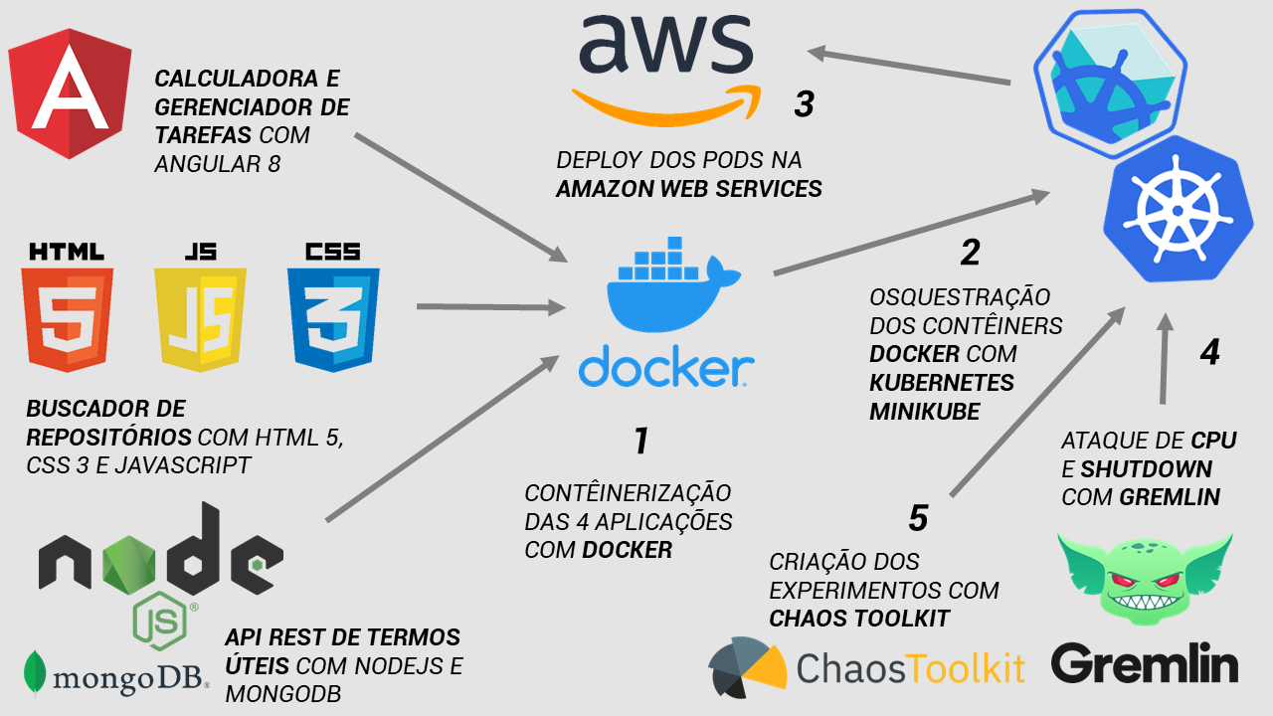
Figure 1 – Research Architecture.

3.3.1. Target Applications
In this subsection we will present the applications that were created to simulate a common production environment to serve as targets for Gremlin and Chaos Toolkit experiments. These applications are divided into four subsections: subsection 3.3.1.1 describing the calculator, 3.3.1.2 describing the task manager, 3.3.1.3 the repository finder, and finally subsection 3.3.1.4 describing the REST API that allows inclusion, removal, editing, listing and searching for useful terms related to Chaos Engineering.

3.3.1.1. Calculator
Developed with Angular 8, the calculator is an application that performs everything a common calculator does: sum, add, subtract, and divide operations. It has a responsive look, the interface adapts regardless of the device the user is using (computer, TV, mobile phone, tablet etc.). Figure 2 shows the graphical interface of this application.
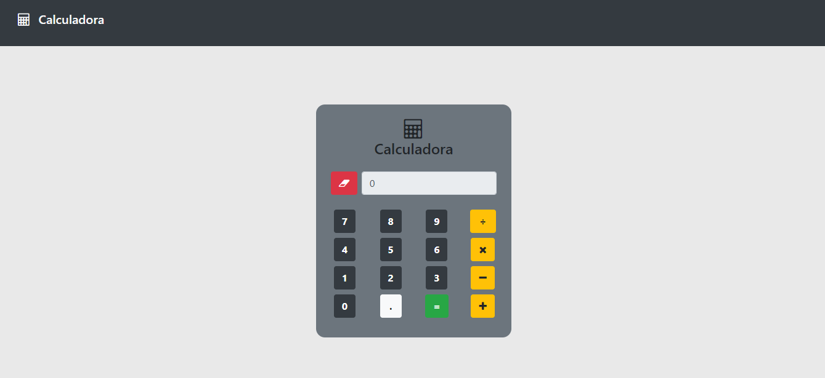
Figure 2 – Calculator in Desktop View.

3.3.1.2. Task Manager
Task Manager is an application which allows the user to add, remove, edit, search, list and change the status of tasks. Developed with Angular version 8, it has a responsive interface and easy interaction. Figure 3 shows what your initial graphical interface looks like without any registered tasks. Above the table that displays tasks, there is a button called "Adicionar Tarefa." Clicking this button displays the task inclusion form graphical interface.
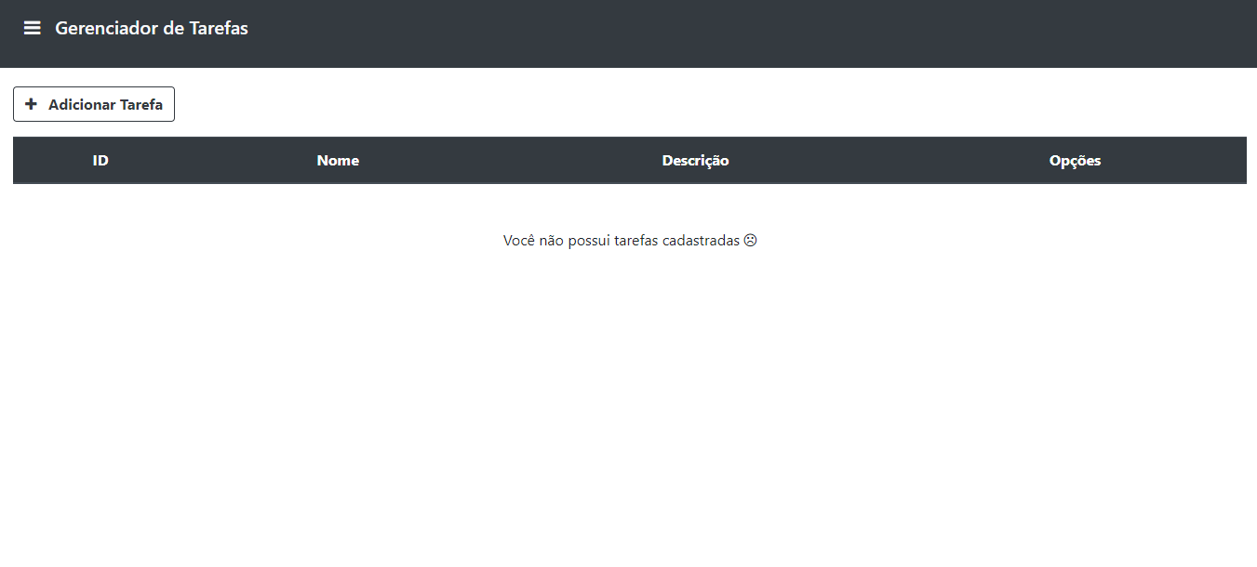
Figure 3 – Initial Graphical Interface Without Tasks.
As soon as the button to add tasks is selected, a form requesting information such as name and description of the task is displayed. Figure 4 illustrates this graphical interface.
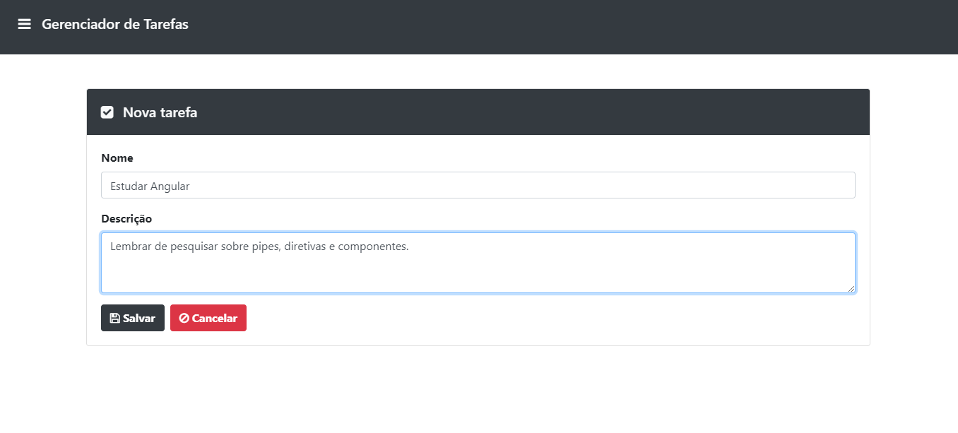
Figure 4 – Task Inclusion Form.
In the task inclusion form it is mandatory to include the name and description of the task. By clicking the cancel button, all form data is lost and the user is guided through the application flow to the task listing graphical interface. If the user clicks the save task button, the form data is saved to the local storage where it is saved on the client side (browser), does not expire, is only removed by the user's action and is displayed formatted and stylized in the graphical interface of task listing as shown in Figure 5 and Figure 6.
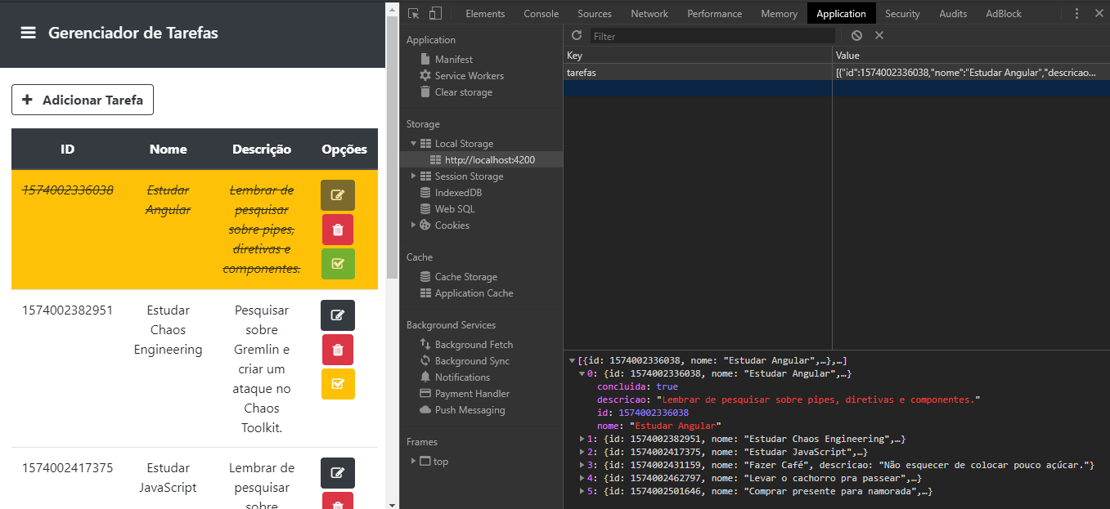
Figure 5 – List of Tasks Saved to Local Storage.
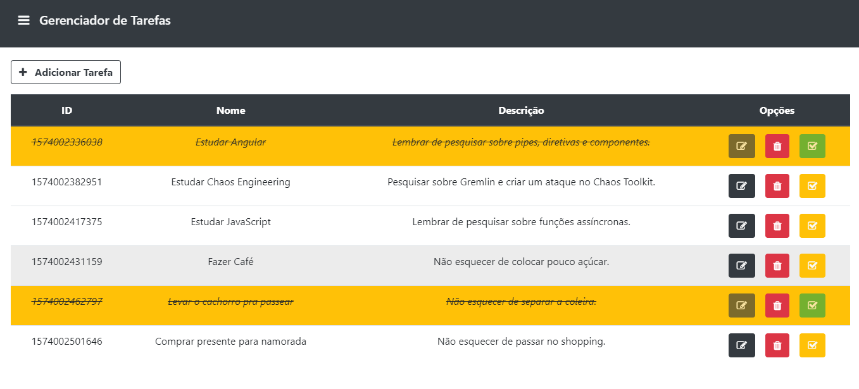
Figure 6 – Tasks List.
Figure 6 illustrates the graphical interface for displaying tasks created in a list. It is possible to see that a table listing tasks has four columns: the first column displays the auto-generated IDs for each task, the second displays the user selected names in the task inclusion form, as in the third column that displays the description. The fourth column displays three buttons, in that order, edit, delete, and change the status of a task to mark as done. It is possible to see in Figure 6 that some tasks have been marked as done, or had their status changed, from this condition, the background color of this task is changed to yellow and the text also has its style changed taxed and italic. Also, it is possible to see that the edit and change status button is disabled, only giving the option to the user delete this task, assuming that the user concludes this task, it cannot be edited or his status changed again.
If the user presses the button to edit a task, the application flow leads the user to the task inclusion form, but as this is an edit, the form is filled in with the user-supplied data before. Figure 7 illustrates this case.
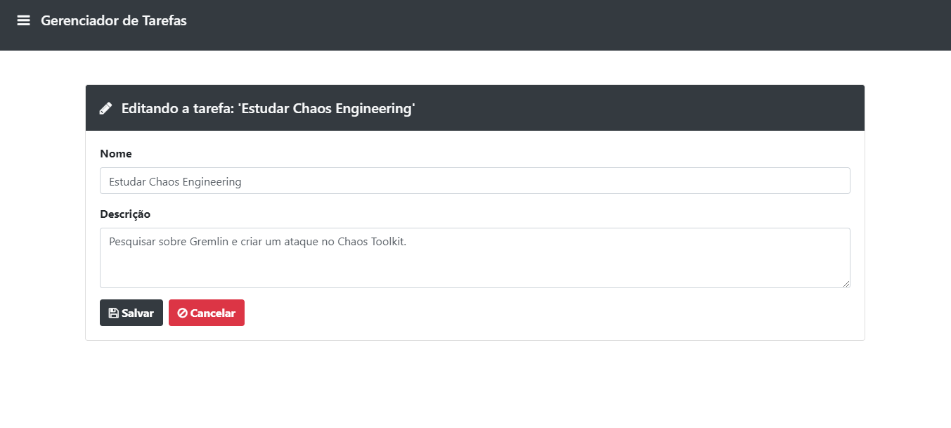
Figure 7 – Graphical Interface for Task Editing.
Figure 7 shows how the task editing graphical interface displays a previously registered task so that its contents can be changed. If the user clicks “Salvar”, all changes are saved back to local storage and the task is displayed updated in the task list, but if the customer clicks “Cancel” nothing is done and the task is displayed again as it was previously.
As shown in Figure 8 it is possible to see which application also makes it possible for the user to delete a task. An alert card is displayed for the user to make sure that the task is deleted.
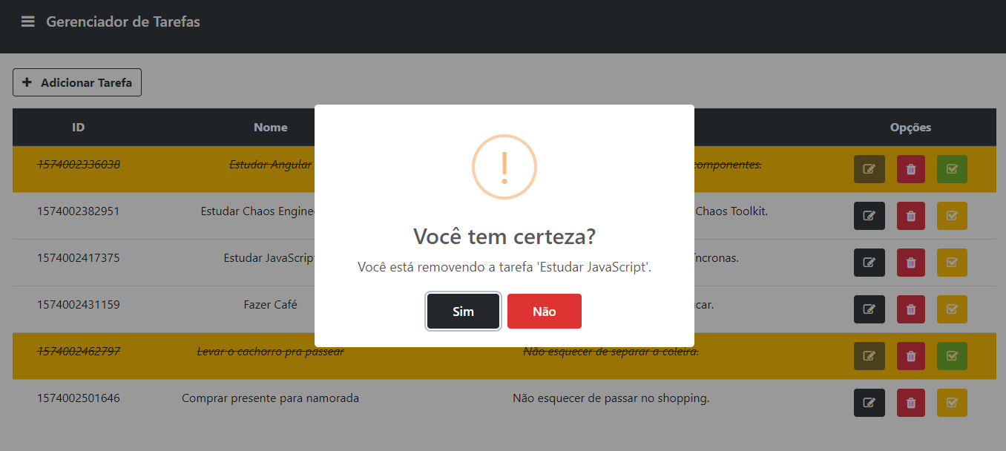
Figure 8 – Task Deletion.
If the user clicks “Cancelar”, the task deletion process is reversed and nothing happens, but clicking “Sim” removes the task from the task list and also from the list in local storage. Figure 9 shows how the modal changes its behavior by displaying a success message to the user if “Sim” is chosen. By clicking "Ok" the user is redirected to the graphical task listing interface.
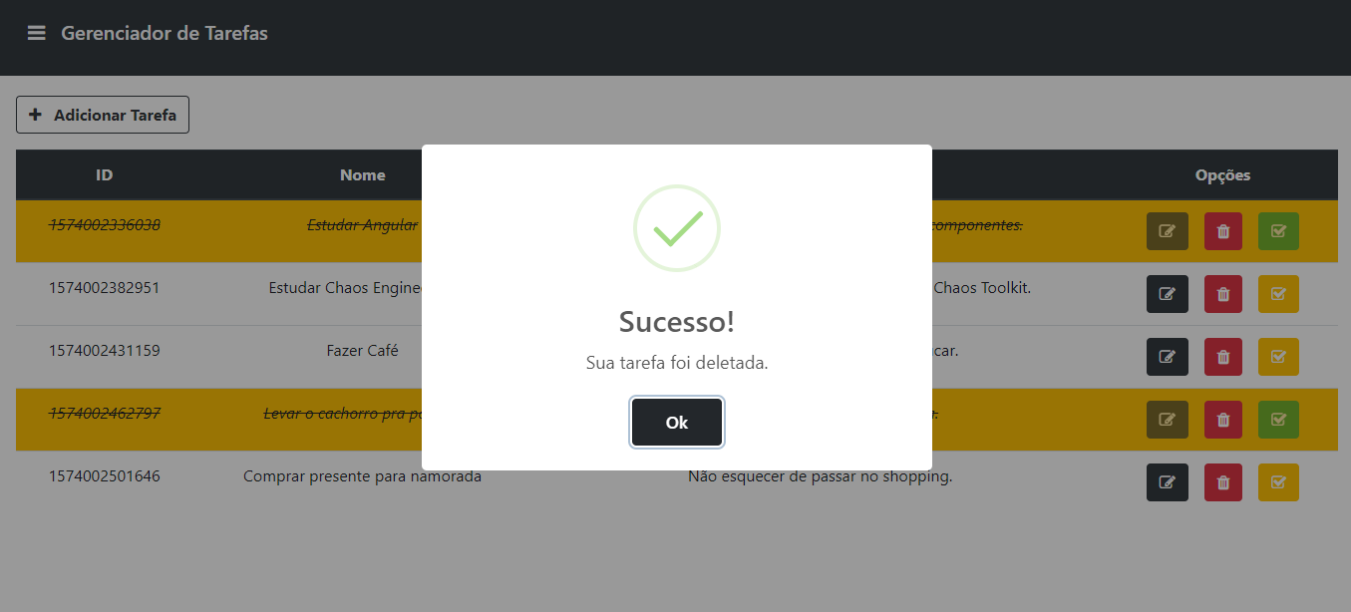
Figure 9 – Success in Removing Tasks.

3.3.1.3. Repository Finder
The Repository Finder is a web application that allows the user to type in any GitHub user name and click the "Pesquisar" button. The application makes a request to the GitHub API for some useful information about the searched user. This user's profile is displayed in the graphical interface containing his name, location and avatar (photo registered in GitHub), besides having a link that acts as an accordion allowing the user to view all public repositories of this searched GitHub member. Developed with HTML, CSS3 with Bootstrap and JavaScript, it has responsive interface and easy interaction. Figure 10 shows what the initial graphical interface looks like without any users being searched.
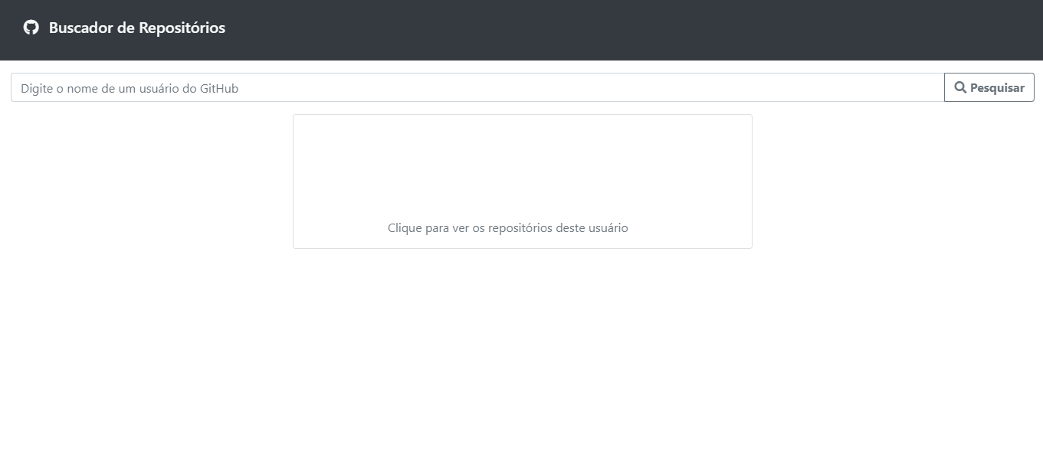
Figure 10 – Repository Finder Home GUI.
Below the card that displays GitHub users, there is a link called “Clique para ver os repositórios deste usuário”. Clicking this link displays the user repository table. If the user has not typed in the search bar, the message “Primeiro digite o nome do usuário” is displayed. Figure 11 shows this behavior.
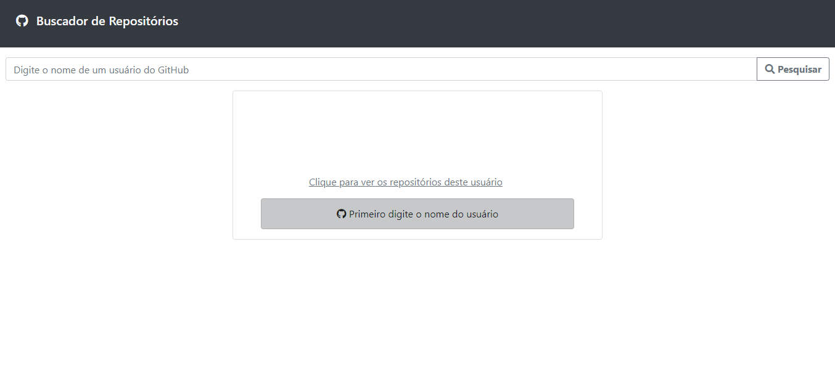
Figure 11 – Accordion With no User in the Search Bar.
By typing “momanhaes” in the search bar it is possible to see the search result. A GET request is made to the GitHub API using the Axios library by passing the user "momanhaes" entered in the search bar as a parameter. If the user does not exist, error 404 is displayed with a custom handling to make the message more user friendly. If the user input field is not filled in and the search button is clicked, an error is displayed in the graphical interface for the user to enter a valid GitHub user. It is possible to see a successful result by looking at Figure 12.
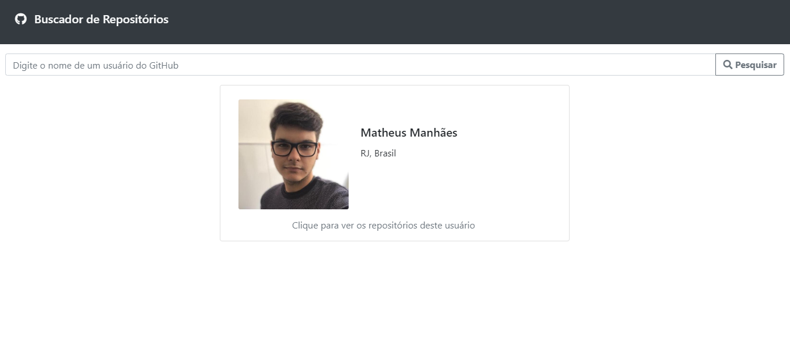
Figure 12 – Repository Finder Success Result.
It is possible, by analyzing Figure 12, that the application brought the “momanhaes” user avatar as well as its location and name to the main graphical interface. By clicking on the link below your photo its possible to check this user's public repositories and forks. In Figure 13 it is possible to analyze this result.

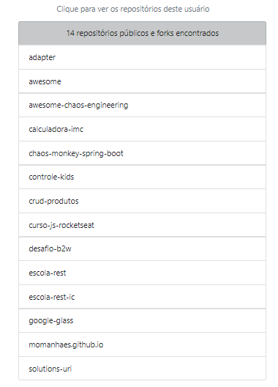
Figure 13 – Accordion on Successful Repository Finder Result.
If it is necessary to search for another GitHub user in the application, all data from the previous search are discarded and the new user data is filled. It is possible to see this behavior in Figure 14. With the data that was previously filled in as a result of the user search “momanhaes”, was searched for the user “felipe-b-oliveira” and the result of this new search overwrote the previous search result.
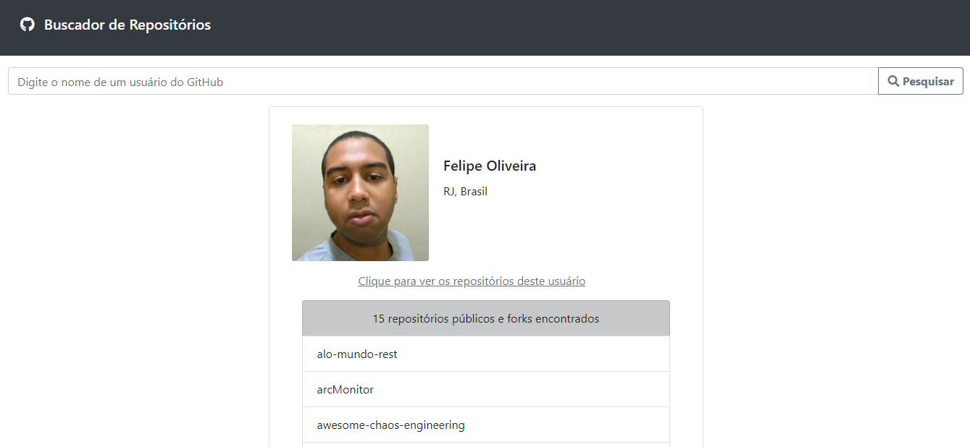
Figure 14 – Repository Finder Success Result Overwritten.

3.3.1.4. Useful Terms REST API
The Useful Terms API is a RESTful server where HTTP verbs are used to make server resources available, and a front-end interface layer application can interact with that server to consume its services. The features used in this API are useful terms from the Chaos Engineering discipline. Is possible to enter a new term, list, edit, delete, and search for a term by its ID. The verbs used on this server are: GET, POST, PUT, DELETE. Where GET will be used exclusively for term search. POST will be used for the creation of new terms. PUT will be used to make changes to existing terms. DELETE will be used for term removal.
A This API was developed using the JavaScript programming language using the Node.js platform. The server was written using Express, a web application development framework that facilitates various routines and provides some features. Data is persisted in MongoDB, a free database software and NoSQL. MongoDB is document oriented, which means that records stored in the bank follow a flexible and adaptable structure. Your documents are similar to JSON format. MongoDB was not installed on a local machine but in a Docker container with the intends to not cause a dependency on persisted data to be on a physical machine.
After have done all the setup to download the MongoDB container, set its name and port forwarding, is required to check which images are available using the docker ps –a command, check which images are running via the docker ps command and go to the browser and type localhost:27017. If the MongoDB image is not running, it is necessary run the docker start mongo command. If the database is available, a message should be displayed in the browser from Docker, as shown in Figure 15. The message says: “It looks like you are trying to access MongoDB over HTTP on the native driver port”.
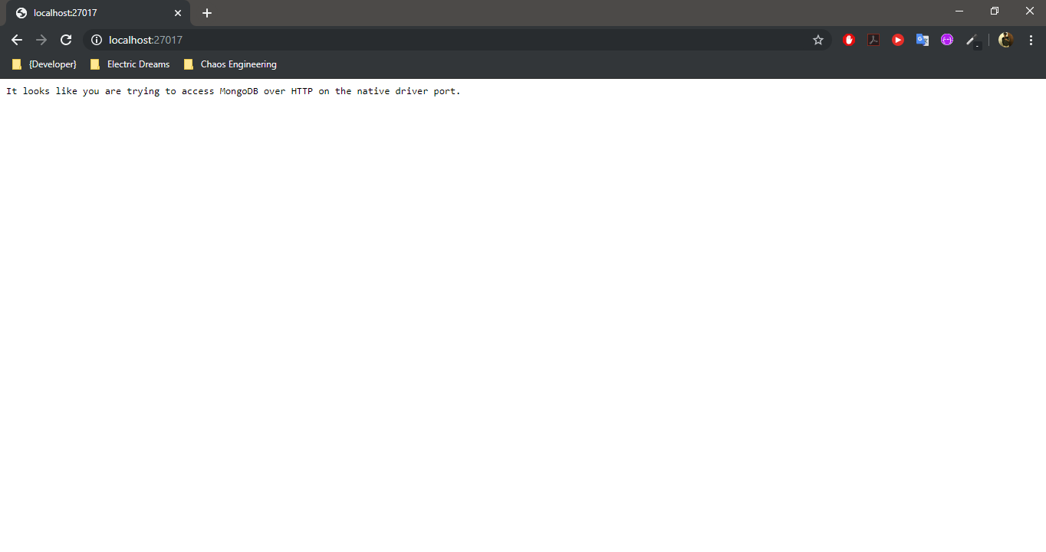
Figure 15 – Docker Success Message.
In order to interact with the API terms, a body, which also serves as a schema for the database, has been defined to standardize the way data will be inserted and edited in the API and consequently persisted in the database. As Figure 16 illustrates, terms will have a name, description, and record log that will be automatically set at each insertion to show the date and time each record was created.
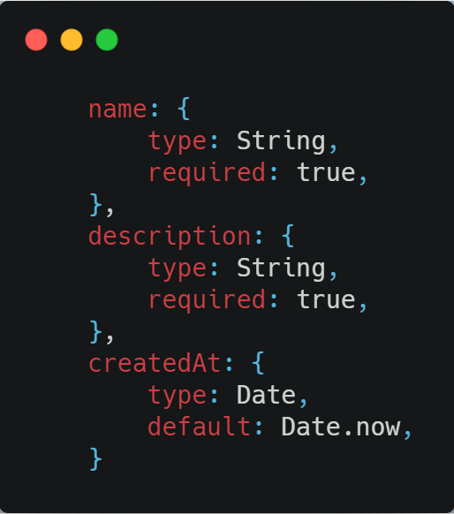
Figure 16 – API Terms Definition Body.
Routes have been created in the API so that it is possible to interact and consume your resources. The entire application context such as routes, schemas, and file naming was prefixed as "attack" as attack is very common in Chaos Engineering's discipline. Therefore, for reasons of visual preference, without affecting the functioning of the API at all, the prefix “attack” was chosen instead of “terms”, since “attack” is better harmonized with the Chaos Engineering discipline, while “terms” has a more generic contextualization.
The routes and their respective HTTP verbs are as follows:
GET /attacks – route used for listing terms.
GET /attacks/:id – route used to list the term that has the ID received as a parameter, that is, will list a specific term according to the ID received by the user.
POST /attacks – route used to create a new term.
PUT /attacks/:id – route used to change data of the term that has the ID received as a parameter, that is, will edit a specific term according to the ID received by the user.
DELETE /attacks/:id – route used to exclude the term that has the ID received as a parameter, that is, will exclude a specific term according to the ID received by the user.
Using Insomnia, a software responsible for storing, organizing and executing REST API requests, it is possible to test each of the routes specified above, thereby enabling, through Insomnia, to create, list, edit, and delete terms from the Chaos Engineering discipline.
In Figure 17 it is possible to analyze an example of term creation with Insomnia, making a POST request to create a new term.
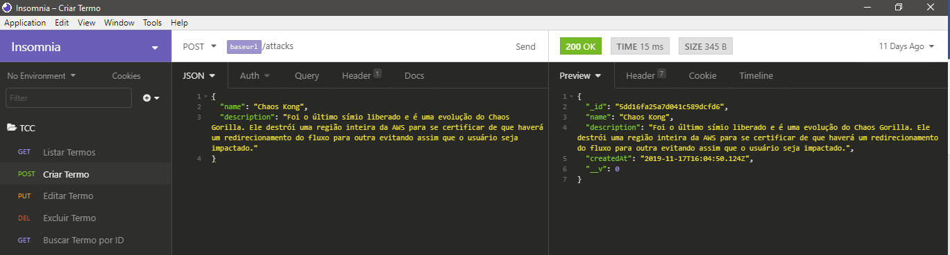
Figure 17 – Creation of Terms in API with Insomnia.
In Figure 18 it is possible to analyze, in another request and this time a GET to list the terms, the previously created term being displayed in the listing, also using Insomnia.
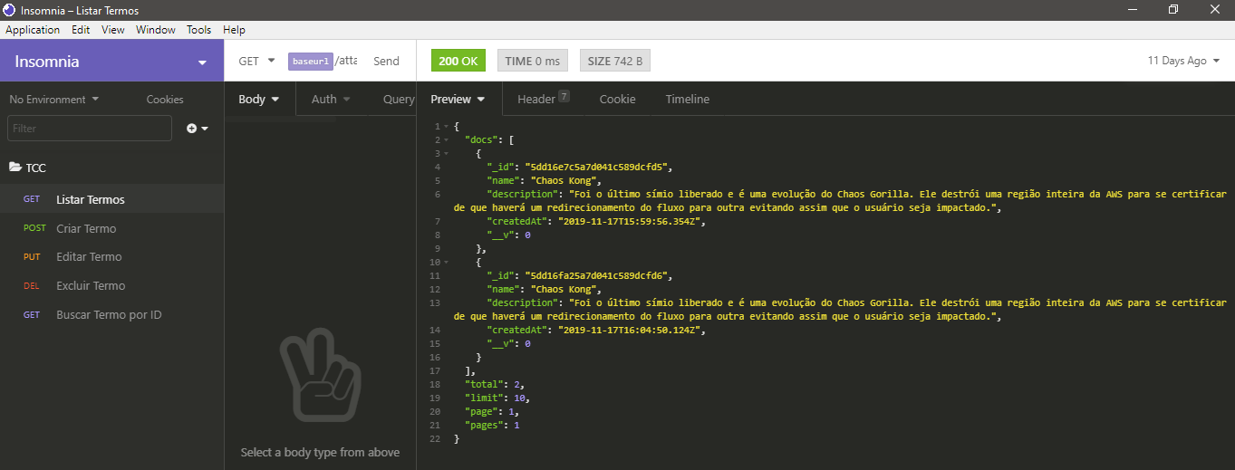
Figure 18 – Listing of Terms in API with Insomnia.
In Figure 18 it is possible to see that with Insomnia it is also possible edit, delete, and search for a term by ID.
In Figure 19 it is also possible to see the result of creating the term with Insomnia by making a request in the browser.
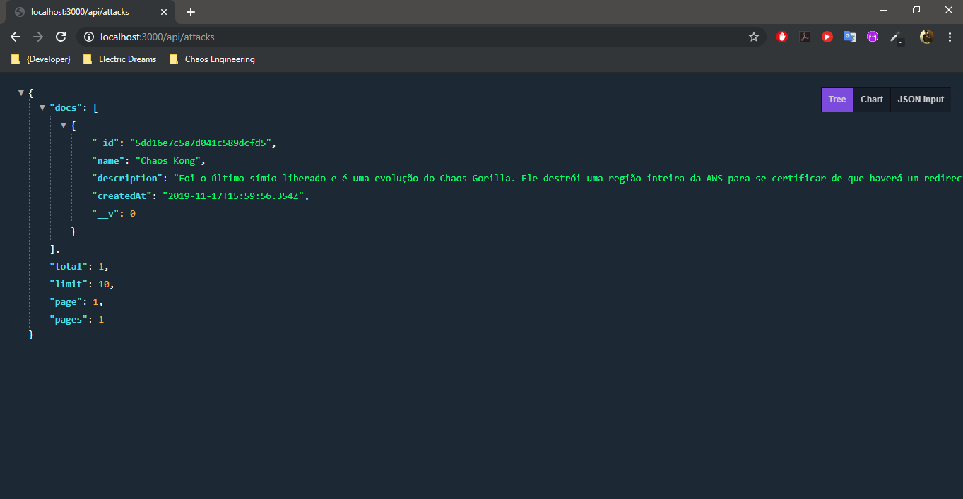
Figure 19 – Terms List of API in Browser.
It is also possible to understand how MongoDB behaves using Robo3T software, a tool that graphically reproduces MongoDB data, since every interaction made is consequently replicated in the database. Figure 20 shows how data is being persisted in Mongo.
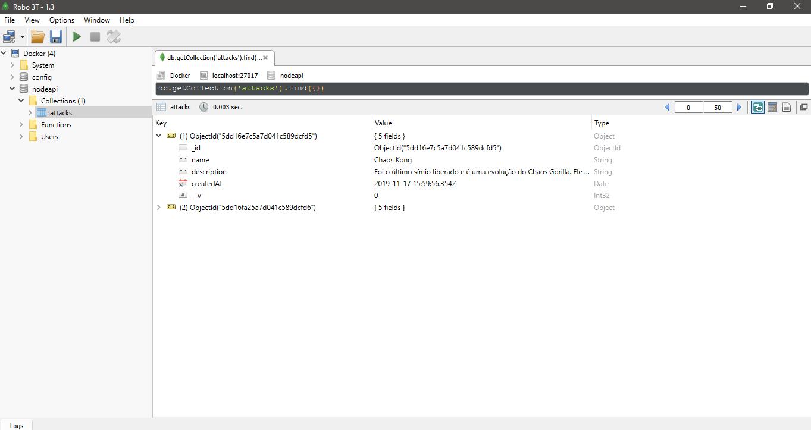
Figure 20 – Term Created in API and Persisted in MongoDB .

3.3.2. Application Containerization
Figure 21 shows the Docker panel called Docker Hub. In it is possible to see all repositories created in order to store a container. It is possible to see in the image that the four applications are listed.

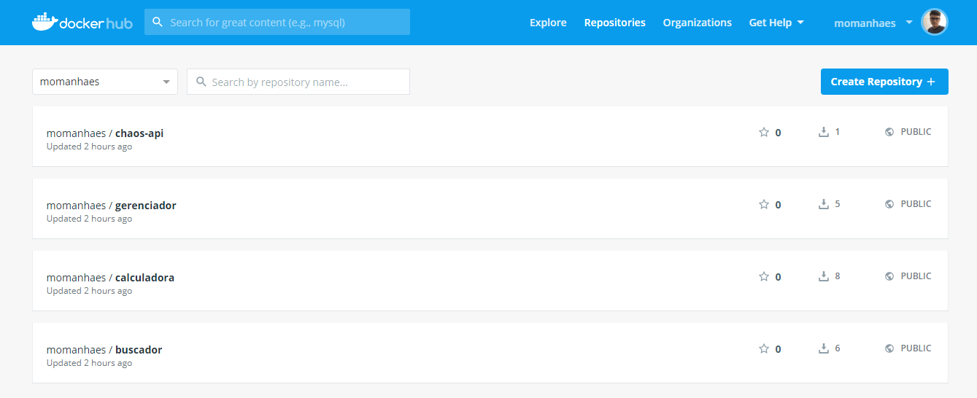
Figure 21 – Docker Hub Displaying Project Applications.

3.3.3. Containers Management
Using Minikube to generate pods and deploy applications to Kubernetes, it is possible to verify that the Kubernetes service is enabled on the Docker Desktop panel. It is important to note that in the deployment files of each application it is possible to define a number of replicas so that, thinking about the process of improving the Chaos Engineering discipline, flow redirection can be done when the pod is dropped. By setting the number of replicas to 1, for example, it is possible to see that Kubernetes takes care of switching between 2 pods managing the application request stream to keep it always available, since Chaos experiments are intended to knock them down. With a few commands and configuration steps, it is possible to access the Kubernetes dashboard and check the status of applications, see how they are being served, and which port to use to access each one. Figure 22 shows how this dashboard is displayed in the Kubernetes panel overview graphical interface.
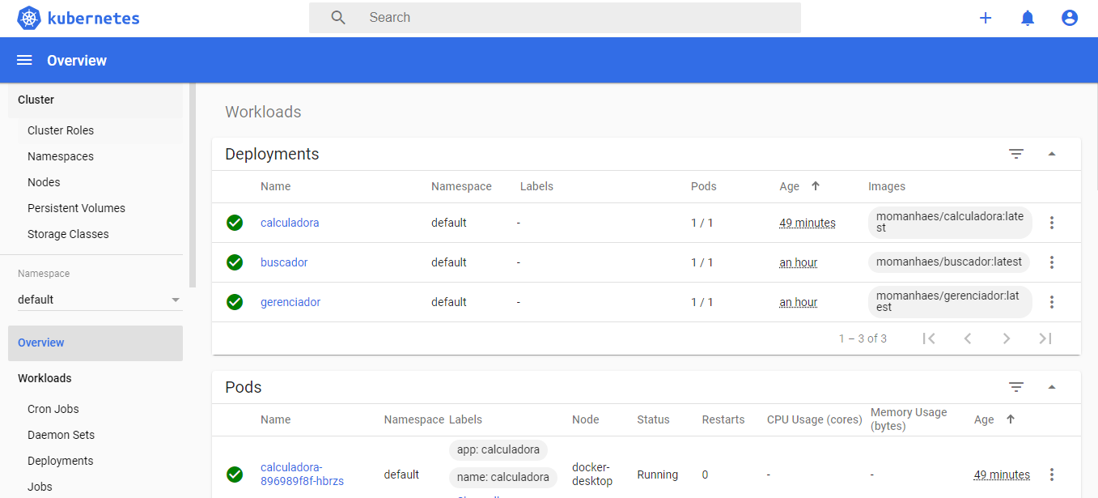
Figure 22 – Kubernetes Overview GUI.

3.3.4. Pods Deploy
Pod is the name given by Kubernetes for a group of one or more containers that are managed by your service. As a good practice of using Kubernetes, it is necessary to use one pod per application. The calculator, task manager, repository finder, and Chaos API will have a separate pod for each, however much it is possible put it the four applications in one pod. All four pods have been configured on Amazon services, AWS. AWS deploys the four pods and provides a virtual machine for the four pods to be serviced and available to users to use without having to separate a physical machine for this purpose. AWS itself is responsible for generating a URL so that it is possible access through it the applications that are in the Kubernetes pods.

3.3.5. Test Execution
This subsection will describe how CPU and Shutdown tests were configured and performed using Gremlin.

3.3.5.1. “Hello World” in Gremlin
In this project Gremlin was the first tool used to generate knowledge of the Chaos Engineering discipline. Although it is limited in its free version, it is possible to do some experiments that will be very useful to analyze the behavior of Gremlin service targets and the application failure generation process.
Before we targeted Gremlin one or even all of the applications created, it was decided to replicate its attacks on a specially crafted virtual machine. Oracle VirtualBox software was used to create a virtual machine using the Linux operating system in its Ubuntu distribution.
By registering on the Gremlin website it is possible to access its panel to study the tool's documentation, configure the attacks, create attack groups and track the outcome of some attacks.
Using a terminal and running the apt-transport-https command it is possible to install Gremlin on the Ubuntu operating system, previously installed on the virtual machine created by VirtualBox. Must also execute the following commands replacing the word “user” with the user created on the Gremlin website and the word “ip_server” with the IP of the server that wish to perform the attack:
ssh user@ip_server
echo "deb https://deb.gremlin.com/ release non-free" |
sudo tee /etc/apt/sources.list.d/gremlin.list.

To import the GPG key it is necessary to execute the command below in the terminal:
sudo apt-key adv --keyserver keyserver.ubuntu.com --recv-keys C81FC2F43A48B25808F9583BDFF170F324D411349CDB294B29A5B1E2E00C24C022E8EF3461A50EF6

Command execution required sudo apt-get update && sudo apt-get install -y gremlin gremlind to install the Gremlin client and daemon.
Once having created an account on the Gremlin website, a verification email will be sent with a link to setup it. In this configuration, a Team ID and Secret Key will be sent to ensure that the environment in which the tests are being run is isolated. These two keys are also required to add new hosts that will be targeted by the attacks. Importantly, each user on the same team has a different Secret Key.
After going through this configuration process using the gremlin init command it is possible to create attacks using Gremlin.

3.3.5.1.1. CPU Attack
By logging into the Gremlin website and clicking on “Create Attack” must be redirected to the attack creation flow.
In the “Choose the Targets” tab must be chosen the host that has been configured to be attacked. Is possible to check the option “Random” for a random choice if multiple hosts are registered.
In the “Choose a Gremlin” tab is possible choose from three available categories. They are “Resource”, “State” and “Network”. Each category has a list of attacks according to each profile. In the free version (version being used) two attacks are available: CPU in the "Resource" category and "Shutdown" in the "State" category. CPU must be chosen from the “Resource” category.
In the “Length” option it is possible to define how long (in seconds) the CPU will be attacked. In “Cores” it is possible define the number of CPU cores that will be attacked. In “CPU Capacity” it is possible to define the percentage of CPU consumption in each core. It will be set to 120 for “Length” and 1 for “Cores” as “CPU Capacity” is not available in the free version.
In the “Run the Attack” tab it is possible to execute the attack or schedule it. Must be click on “Unleash Gremlin” to execute the attack. After have programmed the Gremlin console attack on the site, it is possible check the processor impact caused by Gremlin on Ubuntu using the top command.

3.3.5.2. Gremlin and Kubernetes
After performing the “Hello World” experiment in the previous session by firing a CPU attack on a Linux virtual machine, the same setup procedure was performed in this subsection, but this time the targets are the pods that are serving the calculator and repositories finder. A shutdown attack designed to shut down target pods and a CPU attack designed to increase the CPU consumption of target pods have been created. As shown in Figure 23, it is possible to check the impact of the shutdown attack on pods on the computer console by using the top command.
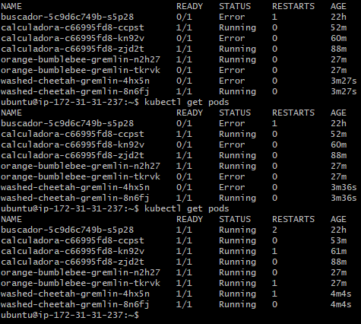
Figure 23 – Result of Gremlin's Shutdown Attack on Kubernetes Pods.
Analyzing the Figure 23, it is possible to verify that pods have been turned off a few times and Kubernetes has had to restart them, as replicas were previously configured for this pod. It is also possible check from the AWS console, as illustrated in Figure 24, the impact of the CPU attack on pods. It is possible to see that at the moment the tests are triggered, the graph shows some peaks in CPU consumption, revealing that the test created in the Gremlin panel was successful.
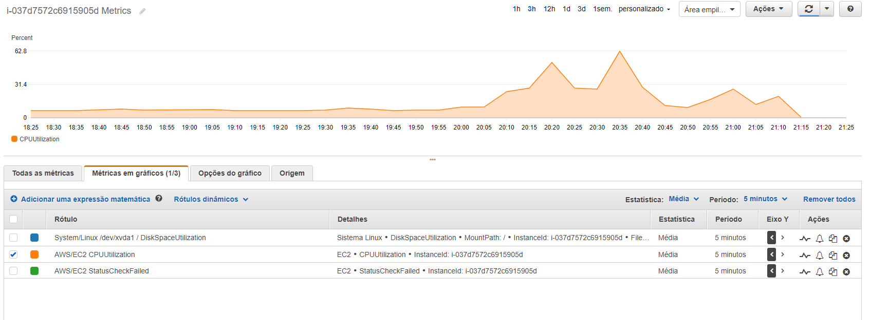
Figure 24 – AWS Console Displaying Gremlin CPU Attack Result.

3.3.4. Test Creation
Just as it is possible to execute attacks through the Gremlin platform, Chaos Toolkit also provides a platform for executing and creating custom tests. For this project was created a test case very similar to the Gremlin shutdown test. Through a document called “chaos-test.json”, it was possible to configure things like the name of the attack, which in this case is “Pod should be automatically killed and restarted when unhealthy”, tags, targets and various other configuration items. It is possible to see in Figure 25 the structure of this attack. By executing the command chaos run chaos-test.json on the terminal it is possible to verify the results of the attack realizing that the application was unavailable in the URL that serves it, just as in the Kubernetes console it is also possible to notice that the application has been shut down and Kubernetes himself took charge of restarting it. Importantly, to run the Chaos Toolkit test requires that the computer has Docker, Minikube, Python, and its PIP package manager.
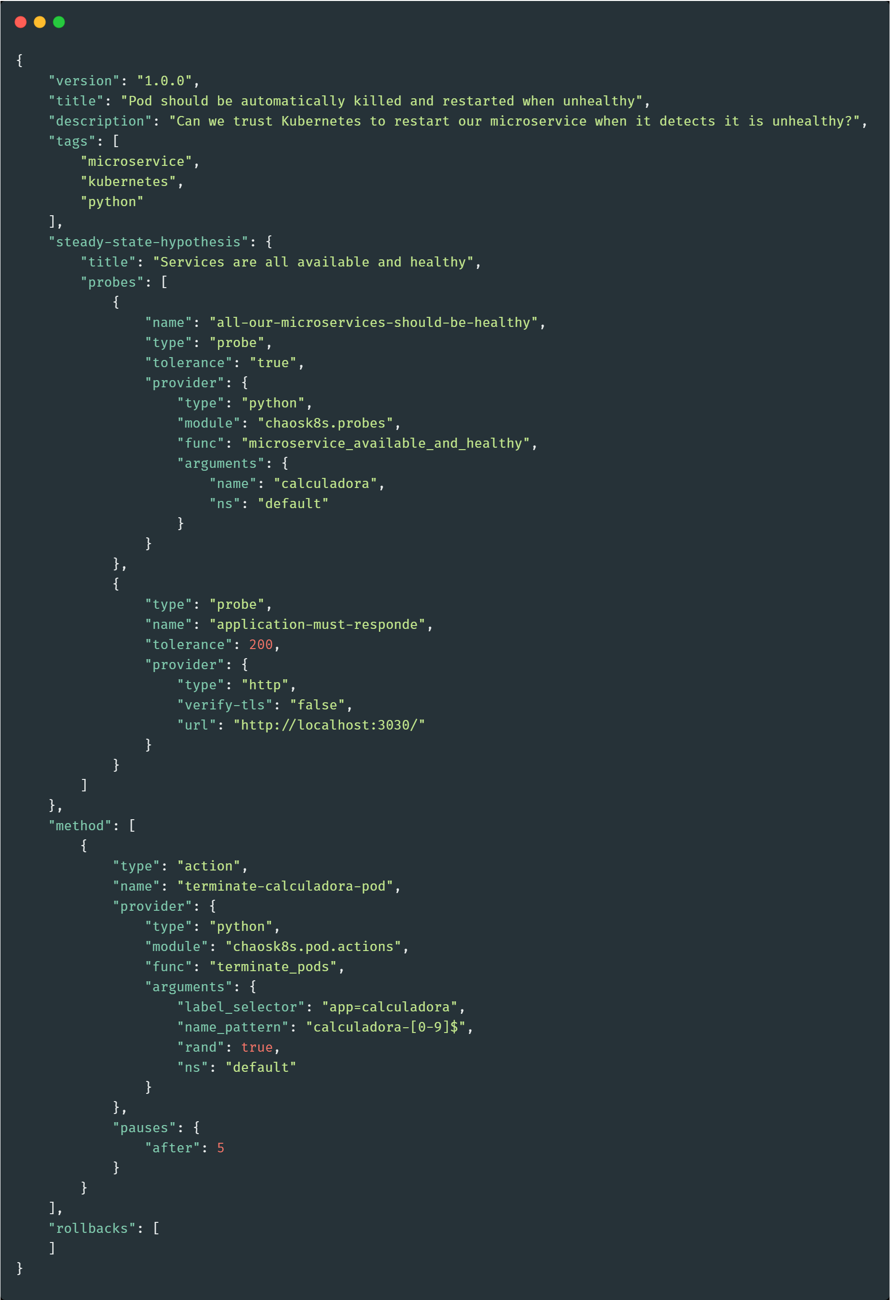
Figure 25 – Attack Created with Chaos Toolkit.
Chaos Toolkit integrates with Latex, the software responsible for creating automatic PDFs of agreements with the log files that Chaos Toolkit generates in your test results. Latex reads the entire file and assembles a PDF, thus generating a slightly more presentable and readable log for the user. It is necessary to install the textlive-latex-base, textlive-fonts-recommended, textlive-fonts-extra, textlive-latex-extra, and pdflatex plugins to generate the PDF document as shown in Figure 26, Figure 27, Figure 28, Figure 29 and Figure 30.
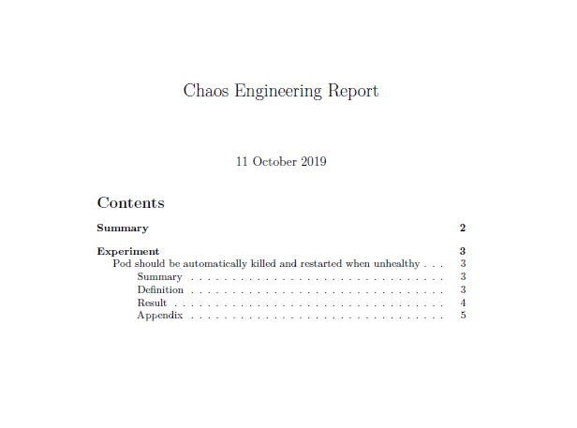
Figure 26 – Chaos Engineering Report of Chaos Toolkit - Page 1.

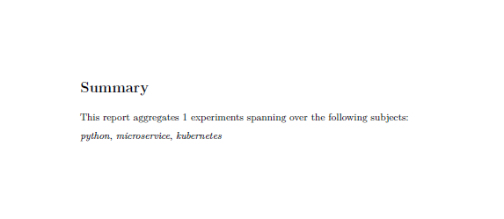
Figure 27 – Chaos Engineering Report of Chaos Toolkit - Page 2.

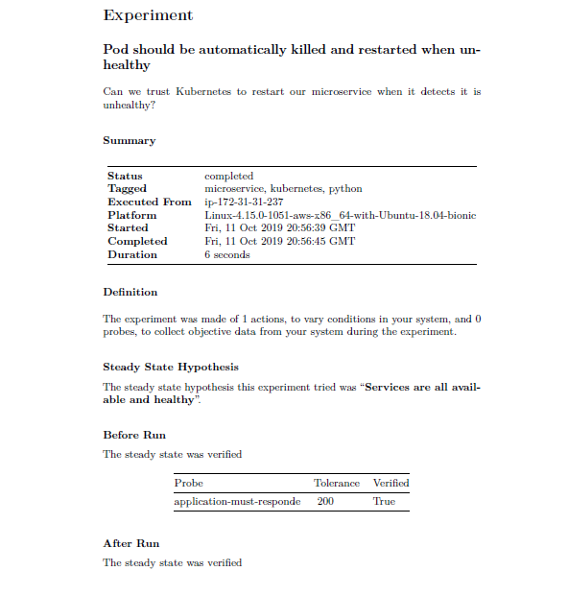
Figure 28 – Chaos Engineering Report of Chaos Toolkit - Page 3.
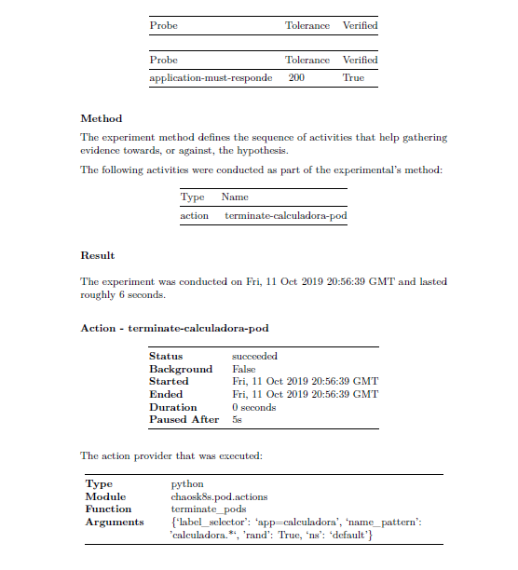
Figure 29 – Chaos Engineering Report of Chaos Toolkit - Page 4.

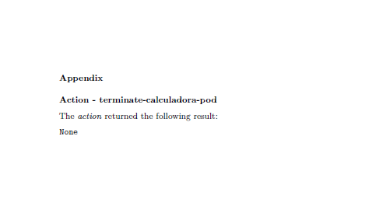
Figure 30 – Chaos Engineering Report of Chaos Toolkit - Page 5.

3.4. Technologies Used
This subsection describes the Chaos Toolkit, Gremlin, Docker, Kubernetes Minikube, and AWS technologies.

3.4.1. Chaos Toolkit
Chaos Toolkit is an open source framework that provides a toolkit for running and creating Chaos Engineering experiments. The framework has two main purposes: providing a complete but simple tool to provide an easy starting point for the discipline application (Chaos Engineering) and providing an open API to the community so that any Chaos experiment can be run consistently using integrations with other emerging tools. Figure 31 shows how this process works.
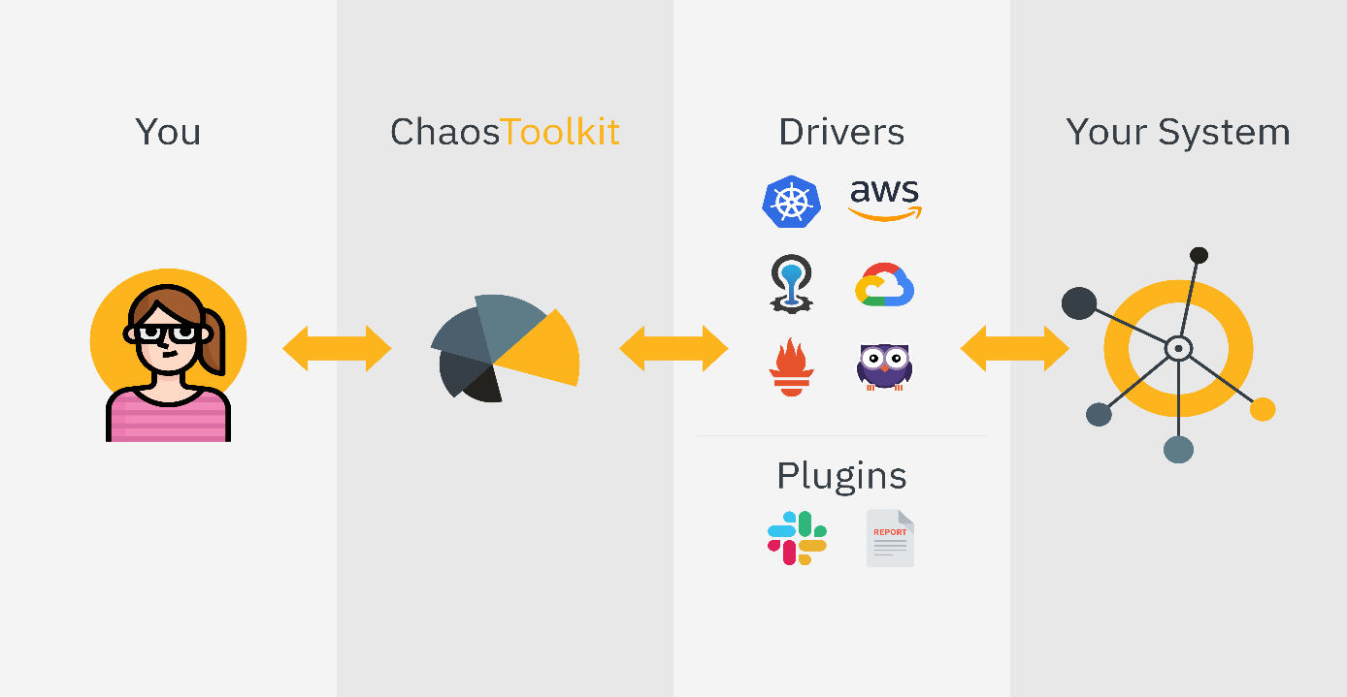
Figure 31 – Chaos Tookit Architecture (Official Documentation, 2019).

The Chaos Toolkit aims to make it simple and straightforward, following the Chaos Engineering Principles, to run experiments against your active system in order to build confidence in your behavior and learn about potential weaknesses.
This tool was chosen to be able to write test. Using the Chaos Toolkit allows to create experiments, run them, and integrate with other services such as Gremlin, Docker, Kubernetes, and AWS.

3.4.2. Gremlin
Gremlin is a paid tool, but it offers some free but limited features. Built to “Turn failure into resilience,” as it says in its documentation, Gremlin offers a framework for safely simulating real outages and with a growing library of attacks. Gremlin falls into the FaaS (Failure as a Service) category, where it provides a platform for users to find weaknesses in their systems before they can cause problems.
Gremlin was chosen because it is possible to perform some experiments that are divided into the categories "Resource", "State" and "Network". Each category has a list of attacks according to each profile. In the free version two attacks are available: CPU in the "Resource" category and "Shutdown" in the "State" category. Choosing Gremlin as a tool for this work allows to perform experiments on increasing server CPU consumption as well as shutting it down programmatically with a few configuration steps.

3.4.3. Docker
Docker is an open platform for application development, submission and execution. Provides the ability to package and run an application in a poorly isolated environment called a container. Isolation and security allow to run many containers simultaneously on a given host.
Docker was chosen for this project, because with Docker it is possible to create images (ready-to-deploy containers) from definition files called Dockerfiles with ease, as well as Docker using LXC as default backend, being possible to define resource limitations by container (memory, CPU and I/O, for example). As such, Docker is ideal for “climbing” the four container applications, as integration with Kubernetes and AWS would also be easy, which will be covered in the next topics.

3.4.4. Kubernetes Minikube
Kubernetes, also called k8s, is an open source platform that automates Linux container operations. This platform eliminates much of the manual processes required to deploy and scale container applications. Kubernetes offers a service so that pods (group of one or more containers) are easily managed.
Already Minikube is a tool that facilitates the local execution of Kubernetes. Minikube runs a single node Kubernetes cluster within a Virtual Machine (VM).
This project makes use of Kubernetes with Minikube as it has a responsibility to manage applications easily and efficiently. Kubernetes is designed to manage clusters that can include hosts in public, private or hybrid clouds. Therefore, Kubernetes is the ideal platform for hosting native cloud applications that require fast scalability, which is essential for the project, as Chaos Engineering tests and experiments will be performed, where it will be necessary, for example, to “climb” services that were dropped, analyze service unavailability and configure stream redirection.

3.4.5. AWS
Amazon Web Services, also known as AWS, is a cloud computing service platform. It is the largest provider of cloud services, offering about 165 complete services application series including computing, storage, databases, networking, analytics, machine learning and artificial intelligence (IA), Internet of Things (IoT), security and application development and management.
AWS was chosen for this project because is not necessary to have to setup and deploy all project configuration and features on one physical machine. It would be extremely complicated to have a computer available and turned on so that we could do the activities of this work, and we have the ability to analyze Amazon's service monitoring graphs, as AWS offers exceptional cloud services where large companies use their resources and offer free services for experimental purposes.

4. Conclusion
This paper presented a Chaos Engineering process with four systems created with HTML, CSS, JavaScript, NodeJS, Angular 8 and MongoDB, using Docker, Kubernetes and AWS to build a production environment and Gremlin and Chaos Toolkit for creating augmentation CPU consumption attack and shutdown of the pods that manage the containers of each application. The results were monitored, analyzed and stored where it was possible to find faults, propose improvements and contribute to the possibility of building more resilient systems.
Considering the hypothesis of improvements, it was possible to realize the risk of unavailability that a system has when it is placed in a turbulent environment. As an example, an attack was performed to shut down the server responsible for serving the calculator. Kubernetes realized that the application had been shut down and automatically uploaded a new server. It was also possible to configure some replicas, that is, copies previously created by Kubernetes to avoid system unavailability, so that the application access flow redirection was done as soon as a container was shut down.
Therefore, the process presented in this paper can be followed by other students, researchers, companies and curious of the Chaos Engineering discipline to verify the feasibility of applying Chaos to their systems, in order to gather the results of the experiments and to choose the best way to do it deal with them.

4.2. Contributions
At the end of the elaboration of this project it is believed that the perceived contributions were the possibility of creating an environment very similar to a production environment so that Chaos Engineering experiments can be performed, as well as the opportunity to identify faults and propose improvements where systems can be built by analyzing these experiments and being able to be more resilient and as close as possible to being “fail-safe”.

4.3. Future Works
Part of what can be done with Chaos Engineering using Gremlin and Chaos Toolkit is demonstrated in this paper. In future research, the goal is to create more test cases with Chaos Toolkit, especially using the useful terms API created for this project, such as increased latency on REST service responses, increased server memory consumption, automatic shutdown non-best practice services, idle service shutdown and automation of experiments using pipelines with continuous integration, where Chaos Engineering experiments run whenever code is updated, as is done with traditional testing.

5. Bibliographic References
AWS. AWS Documentation.
Available in: https://docs.aws.amazon.com/index.html?nc2=h_ql_doc_do_v.
Angular. Angular Documentation. Available in: https://angular.io/docs.
Bootstrap. Bootstrap Documentation. Available in:
https://getbootstrap.com/docs/4.3/getting-started/introduction.
Chaos Toolkit. Chaos Tookit Site. Available in: https://docs.chaostoolkit.org.
Docker. Docker Documentation. Available in: https://docs.docker.com.
GitHub Chaos Toolkit. Chaos Tookit Documentation. Available in: https://github.com/chaostoolkit/chaostoolkit.
Gremlin. Gremlin Documentation. Available in: https://www.gremlin.com/docs.
IBM. Escalabilidade e elasticidade para padrões de aplicativo virtual no IBM PureApplication System. IBM. 2013. Available in: https://www.ibm.com/developerworks/br/websphere/techjournal/1309_tost/index.html.
JANOWSKI, Daniele Andrea. A Televisão como Agente de Entretenimento e Formação. Curitiba, 2011.
Kubernetes Concepts. What is a pod? Available in: https://kubernetes.io/docs/concepts/workloads/pods/pod.
Kubernetes. Getting Started – Installing Kubernetes with Minikube. Available in: https://kubernetes.io/docs/setup/learning-environment/minikube.
Kubernetes. Official Site. Available in: https://kubernetes.io/pt/docs/home.
LIMA, Cecília Almeida et al. Netflix e a manutenção de gêneros televisivos fora de fluxo. São Paulo, 2011.
MDN Web Docs. JavaScript Documentation. Available in: https://developer.mozilla.org/pt-BR/docs/Aprender/JavaScript.
MODESTO, Jean Klebert de Albuquerque et al. Aplicações Web e as suas Principais Vulnerabilidades. Rio de Janeiro, 2015.
MILES, Russ. Learning Chaos Engineering: Discovering and Overcoming Weakness through Experimentation. California: Oreilly, 2019.
Mundo Docker. O que é Docker? Available in: https://www.mundodocker.com.br/o-que-e-docker.
MUNIZ, Antonio. Jornada DevOps: Unindo cultura ágil, Lean e tecnologia para entrega de software com qualidade. Rio de Janeiro: Brasport, 2019.
Netflix. About Netflix. Site. Available in: https://media.netflix.com/pt_br/about-netflix.
Node.js. About Node.js. Available in: https://nodejs.org/pt-br/about.
Red Hat. O que é Kubernetes? Available in: https://www.redhat.com/pt-br/topics/containers/what-is-kubernetes.
ROSENTHAL, Casey et al. Chaos Engineering: Building Confidence in System Behavior through Experiments. Oreilly, 2017. Available in: https://www.oreilly.com/ideas/chaos-engineering.
AWS Official Web Site. O que é AWS? Available in: https://aws.amazon.com/pt/what-is-aws.
STELLA. Report from the SNAFUcatchers Workshop on Coping with Complexity. Available in: https://snafucatchers.github.io.
W3Schools. HTML Tutorial. Available in: https://www.w3schools.com/html.
W3Schools. CSS Tutorial. Available in: https://www.w3schools.com/css.

